Technology Skills: Graphic Design

Project: Leukemia-Lymphoma Awareness Website

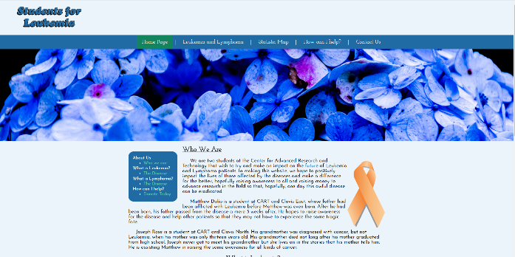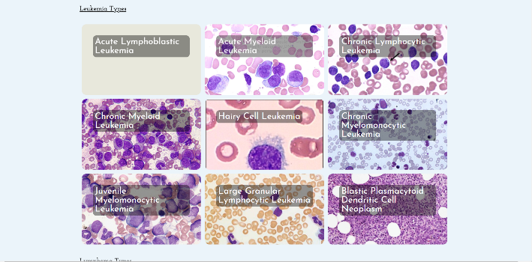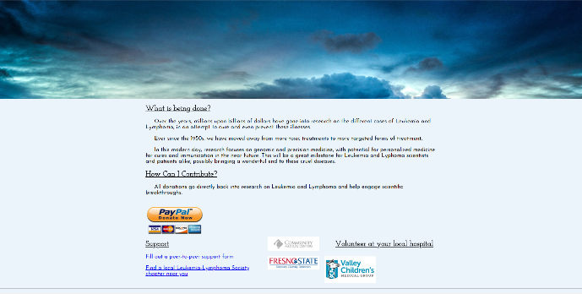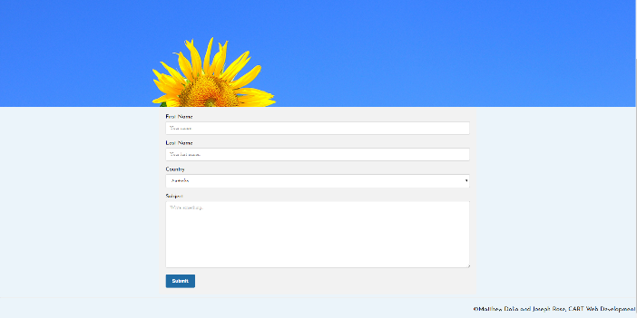

Here are several screenshots taken from different pages of a website I made with another student about leukemia and lymphoma. This project had us taking a topic of our choice that needed awareness and explaining it and how to help. I did not have as much input in the coding, but I was a major part in designing the look and writing the text for the website. A random fact I learned during this is that, while the famous ribbon represents cancer awareness, the ribbon’s color represents awareness for different kinds of cancer. For example, orange represents leukemia and lymphoma awareness.

The most frustrating, yet most rewarding part of our website was the different definitions we put for different types of leukemia. We put several boxes that, when hovered over with the mouse, would fade into another box with the description of that disease. It was insanely frustrating hiding the text and making it appear only when the mouse hovered over it. Another issue arose when the area that the hover worked often extended into other boxes. Once we smoothed out those issues, we were so satisfied with the final result. Our website might not have been the most colorful or pretty, but it had the most unique functionality.

Most of the problem solving process involved us asking questions about the problem. We had to ask why the box extended so far, where in the code the problem occurred, and what can be done to fix it. It took a lot of outside-the-box thinking to discover ways to solve the issues we found. We even had to take a look at our thought process to figure out what we were thinking when we wrote the code to realize why the code was wrong.